STRS report for OSURA Board, May 2021. G. Newsom
STRS news
The deadline for voting for retired members of the STRS Board was May 3. Some highly misleading emails were sent out by “ike1,” attacking the current Board. We should know the results in a week or two.
The Ohio School Employees’ Retirement System has lowered its assumed return on investment from 7.5% to 7.0%, which increased its unfunded liability by $185 million. The STRS assumption of 7.45% is looking anomalously high. For 131 public pension systems surveyed across the country, the average was 7.14%, with a high of 8.0% (Arkansas State Highway ERS and Ohio Police & Fire) and a low of 5.25% (Kentucky ERS).
Retirement applications for public school teachers in Ohio are up sharply this year compared to the last two years, most likely COVID-related. As of mid-April, STRS was on pace to have 4000 retirements this year, compared to 2700 in FY 2020 and 3100 in FY 2019.
A major function of the STRS Board is deciding what fraction of assets should be invested in different asset classes; that will next happen in March of 2022. Each class has a trade-off between expected return and expected risk, as shown in the graph below prepared by Callan consultants for the Board. Over the long haul, it’s hard to beat equities among classes considered here, but equities also carry the greatest risk.
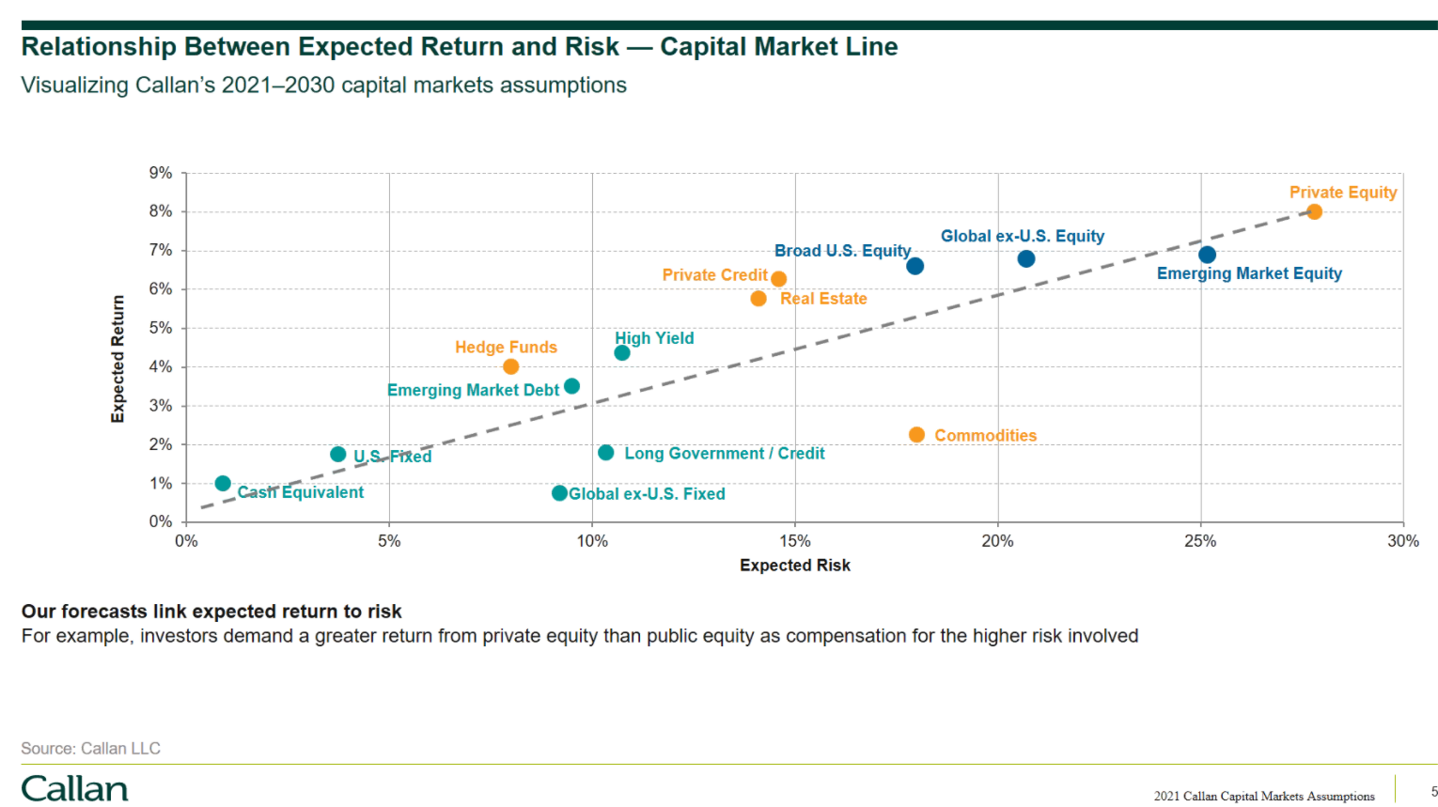
As part of the fiduciary training the Board goes through once or twice a year, the Board was reminded of the Ohio Revised Code stipulation in ORC 3307.15, which says STRS is responsible for “diversifying the investments of the system so as to minimize the risk of large losses, unless under the circumstances it is clearly prudent not to do so.” Thank goodness that last clause is there. If the sole goal is to minimize risk, then just keep all assets in cash, with negligible return. But since investment returns pay most of our pension payments, such a move would guarantee in the future either pensions would be only a small fraction of what they are now or employee and employer contributions would be drastically increased.
The financial outlook presented to the Board in April was upbeat. The vaccine rollout and opening of the economy plus the supportive fiscal policy (the stimulus bills) and monetary policy (low interest rates set by the Fed) bode well, even though interest rates are expected to rise modestly.
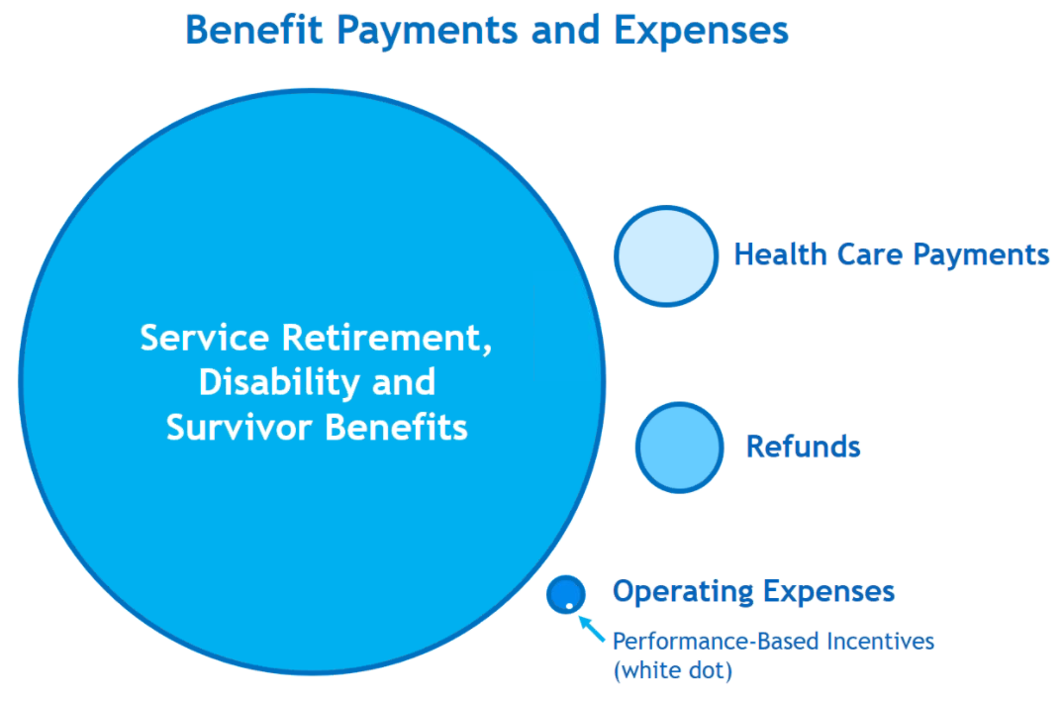
Bonuses (or performance-based incentives) for investment managers have been a lively topic among those criticizing the STRS Board and played a role in campaigning in the current election for Board members. Some have claimed retirees would be better off if money for the bonuses were put into pensions instead. The graph at right shows relative annual expenses for STRS. The message is that bonuses are absolutely trivial compared to pension payments.
Costs for health care have been down 10% to 20% and if good investment returns are assumed, the funded ratio has likely exceeded 200%. The staff presented preliminary plans for the 2022 health insurance to the Board, including a $15 cut in 30-year benefit recipient premium and a $40 cut in spouse premium, with final numbers to be approved at the June STRS meeting.
Legislative news and reports from other states
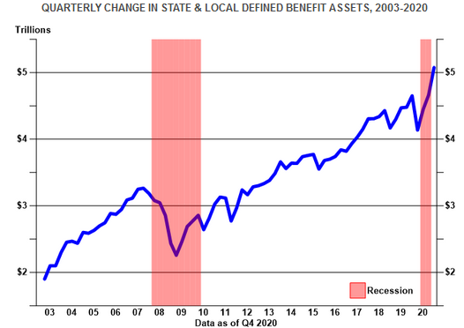
If one just heard criticisms of public defined benefit (DB) plans, one could believe they are in terrible financial shape. The graph at right of their assets vs. time paints a very different picture. While pension obligations have increased considerably in recent decades, the plans still have a lot of money.
However, some states have pension problems. The chronically underfunded New Jersey pension system, with its $100 billion unfunded liability, got some good news (maybe) when the governor promised that next fiscal year the state will make its full payment to the pension fund (a real novelty in New Jersey). The Vermont legislature had proposed to overhaul the state pension systems to address a $3 billion shortfall, but following criticism, legislative leaders agreed instead to create a task force to study the problem. A report on public pensions in Illinois concluded that state and local governments will likely shift more of the pension costs to schools, colleges, and universities. Criticism of the Pennsylvania pension system has increased, with both an internal investigation and a federal probe underway, and some employees will see their contribution rates increased. Florida may convert the state’s defined benefit (DB) plan to a 401(k)-style defined contribution (DC) plan. Kentucky replaced its Kentucky Retirement Systems with a new Kentucky Public Pensions Authority, with a large salary increase for its investment chief, and the legislature had passed a bill to put new teachers in a “hybrid” pension plan which combines DB and DC plans. Teachers generally opposed the change and the governor vetoed the bill, but the legislature has overridden the veto.
AARP reports millions of older employees were forced to take retirement earlier than they’d planned because of the pandemic. The people who were most hit financially were low-income, minorities, and older workers. The number of retiring Americans who won’t be able to maintain their pre-retirement standard of living as gone up from 50% previously to 55% now. Downward mobility is in the cards for many.

