STRS report for the OSURA Board, August 2021. G. Newsom
Many of us recently received another mailing from POP5, asking for money to help fight for our pensions. I note that OCHER (the Ohio Council of Higher Education Retirees) considered POP5 a couple years ago and could not see what it provides that is not already provided by OCHER, HPA, ORTA, and PERI. OCHER voted to not recognize POP5.
STRS news
Much has transpired in the last two months. Bob Stein, just re-elected to the Board, resigned for personal reasons. We just lost a lot of institutional memory and a good source of information on what was going on at STRS. In past years, the Board had an annual retreat where, under the guidance of a facilitator, the Board studied how it functioned, how it could improve, etc. The facilitator in recent years commented on how well the Board managed, with members respecting each other even if (on rare occasions) they disagreed on some policy. I’d love to be wrong on this, but this era seems to be ending. Newly elected Rudy Fichtenbaum circulated a report highly critical of some of the Board members, and Wade Steen (governor’s appointee, appointed by Kasich and re-appointed by DeWine) made very unflattering comments about STRS staff at the last Board meeting. (I note, however, that as far as I’ve seen, Fichtenbaum’s verbal comments were much more restrained and reasonable than his written words.) Much of the changed atmosphere apparently was triggered by the “forensic investigation” by Ted Siedle, commissioned by ORTA (Ohio Retired Teachers Association). (There’s a new effort to raise funds to pay Siedle to go after OPERS next, so STRS may have company.)
The Siedle report is 127 pages long, claiming to find examples of massive mismanagement that has cost STRS dearly. Many of the claims cannot easily be checked by someone outside the system, but I did see two examples of what looked to me to be significant errors. Siedle met with HPA (Healthcare and Pension Advocates, a “users” group that offers advice to STRS), my chance to ask for clarifications on my two examples. I think it’s fair to say that one important point in Siedle’s report was highly misleading, and the other was just plain wrong. STRS staff are in a much better position to examine the many other accusations. I would not be at all surprised if they found other examples that are not substantiated, but perhaps some of the claims could improve how STRS manages their investments. HPA unanimously felt that the STRS staff and Board need to present a detailed rebuttal to each point in Siedle’s report; they need to either explain why it is not valid or explain how it can be used as a constructive suggestion to improve operations at STRS. The response is expected at the August Board meeting, which could easily spill into a second day as charges are examined in detail. The legislature did not authorize retirement boards to continue with virtual meetings, so we expect to have in-person meetings starting this month. The Dispatch had an article (online on 22 July and print edition on 24 July) starting with, “There is trouble in the board room at the State Teachers Retirement System of Ohio ...” The article says that Steen knows how “STRS can reduce its investment fees, dramatically drop the required contribution rates, allow teachers to retire at younger ages and bring back the cost to living allowance.” The phrase “if it sounds too good to be true ...” comes to mind here, but let’s see where it leads.
What does this mean for the future of STRS? Here are two scenarios that seem unlikely to me. (1) Supporters of the challenge to the STRS establishment have urged retirees to write their legislators to protest how the program is being managed. For conservative politicians who don’t like public defined benefit (DB) retirement plans, this could be their chance to convert STRS to a defined contribution (DC) plan. Groups such as ALEC have been pushing for changes that would effectively end STRS as a DB plan. This would not be good for future retirees, but likely would not affect current retirees. Should that happen, investment firms managing accounts for retirees in DC plans could make a lot of money. (2) Perhaps Siedle really is on to something and he could greatly improve finances at STRS.
We are more likely to see a mixture of less momentous changes. Board members in recent months have been commenting more often that they need to provide some inflationary adjustment for retirees, and the big jump in the CPI in July can only add to that pressure. In the first 11 months of FY 2021, STRS investments returned 27.01%, greatly improving their financial position, but the higher stock prices that drove these returns also mean the price to earnings ratios now makes stocks less attractive. On advice of consultants, the STRS Board voted to reduce the assumed rate of return going forward to 7.00% from the previous 7.45%. This change I think precludes the return of the 2% COLA, but at least a one-time increase in pensions would not be surprising. The atmosphere at STRS is likely to become more contentious and less friendly. Whether this makes it harder to keep their top staff remains to be seen, but it’s hard to see morale remaining high when Board members make public claims of low competence among the staff. If the disgruntled members of the Board curtail the performance bonuses given to investment staff, that could lead to lower returns down the road.
The bright spot is that 88% of enrollees in the STRS healthcare plan will see a decrease in their premiums next year. However, non-Medicare enrollees will see an increase, a trend that seems likely to continue in future years.
News from other states and legislative report
The Missouri Public Schools Retirement System reduced its assumed return on investments from 7.5% to 7.3%, New Jersey reduced theirs from 7.3% to 7%, Kentucky reduced theirs from 7.5% to 7.1%. Nebraska is reducing their 7.50% assumption to 7.30% for FY 2021, dropping each year thereafter until it reaches 7.0% in FY 2024. The Illinois State Universities Retirement System reduced its assumed rate of return from 6.75% to 6.5%.
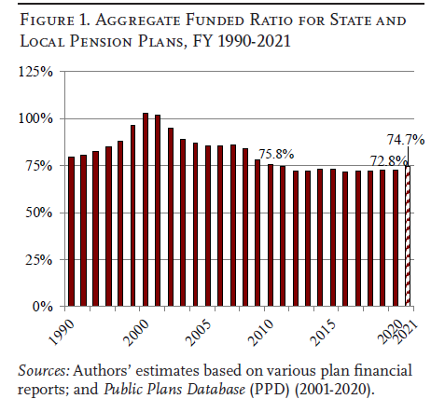
The Center for Retirement Research at Boston College produced the graph at right, showing the ratio of assets to liabilities for state and local pension funds across the country. Things looked so flush in 2000 and 2001, leading STRS and other pension funds to increase pension payments, just before the economy tanked. As expected investment returns have declined in recent years, many pension plans have reduced or ended COLAs and/or increased contributions in order the keep the funded ratio pretty steady.

